**Sprint 2 Report**

**Actions to Stop Doing**

The team should stop working on branches that are already merged so that merging issues can be avoided.

**Actions to Start Doing**

Team members should share phone numbers with each other and be on Discord more often so that it is easier for members to communicate with each other.

**Actions to Keep Doing**

The team should continue to hold regular meetings so that team members remain up to date with the project’s status.

Team members should continue to ask questions on Discord in order to prevent their confusion from impeding the project’s progress.

**Work Completed**

All six of the user stories were completed during Sprint 2. The user stories were the following -

* As a reader, I would like to be able to search for specific comics so that I can easily find content that interests me.
* As a reader, I would like to be able to return to the last page I read so that I can easily pick up where I left off.
* As a reader, I want the viewing experience to be smooth, even when my connection is poor, so that I can read the comics with greater ease.
* As an administrator, I want to be able to remove inappropriate content so that I can maintain the integrity of the web comic viewer.
* As an administrator, I want to be able to ban problematic account users so that I can prevent repeat offenses from occuring.
* As an administrator, I want to be able to communicate issues with account users so that they understand what violations they made.

Thus, nothing was left incomplete.

**Burn Up Chart**

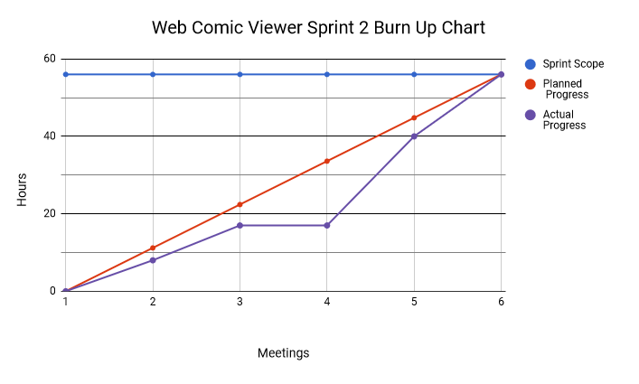

**Work Completion Rate**

All six of the user stories were completed in Sprint 2. As a result, 56 ideal hours were completed in total. The sprint lasted 15 days, 4 of which were weekends. Therefore, the ideal hours/day for Sprint 2 is 3.73 and the user stories/day for Sprint 2 is 0.4. By combining the results of Sprint 1 with the results of Sprint 2, the average ideal hours/day becomes 4.81 and the average user stories/day becomes 0.37.